[Customer Service Analytics and Reporting Solutions (servicenow.com)](https://docs.servicenow.com/bundle/sandiego-customer-service-management/page/use/dashboards/application-content-packs/customer-service-content-pack.html)

[Performance Analytics - Content Pack - Customer Service | System Plugin | ServiceNow (service-now.com)](https://dev142219.service-now.com/nav_to.do?uri=%2Fv_plugin.do%3Fsys_id%3Dcom.snc.pa.customer_service%26sysparm_stack%3D$allappsmgmt.do%253Fsysparm_search%253Dcom.snc.pa.customer_service)

Paid plugin

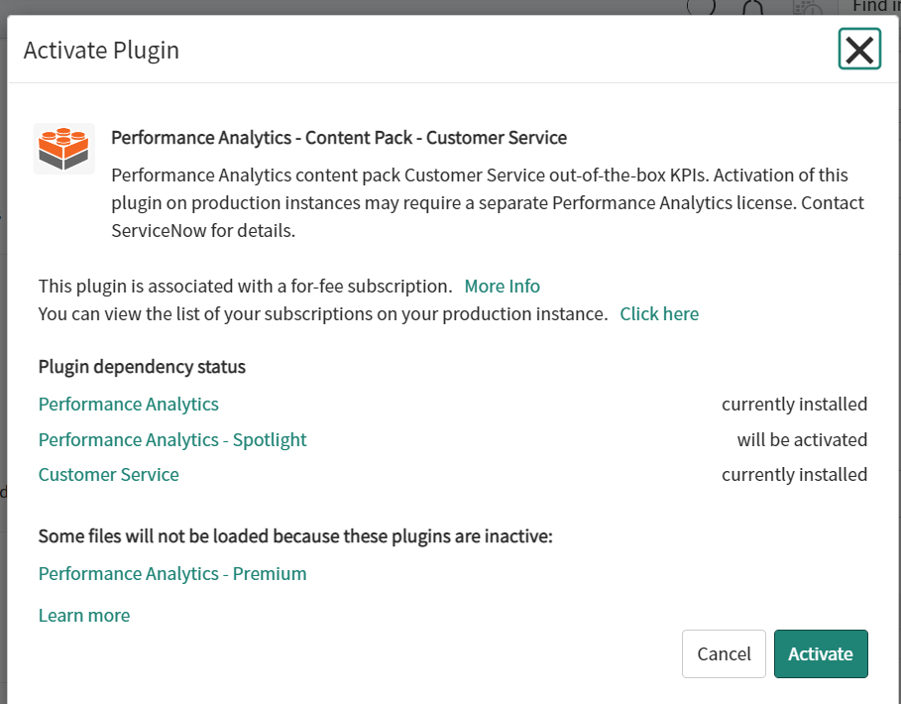

[Performance Analytics - Content Pack - Customer Service Management - Advanced | System Plugin | ServiceNow (service-now.com)](https://dev142219.service-now.com/nav_to.do?uri=%2Fv_plugin.do%3Fsys_id%3Dsnc.pa.customer_service_advanced%26sysparm_stack%3D$allappsmgmt.do%253Fsysparm_search%253Dcom.snc.pa.customer_service_advanced)